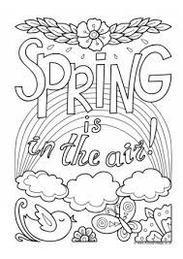
Hi everyone hope you’re all excited that springtime has finally started. For today’s boredom buster we have a few printable activities to help banish any boredom you may be feeling.

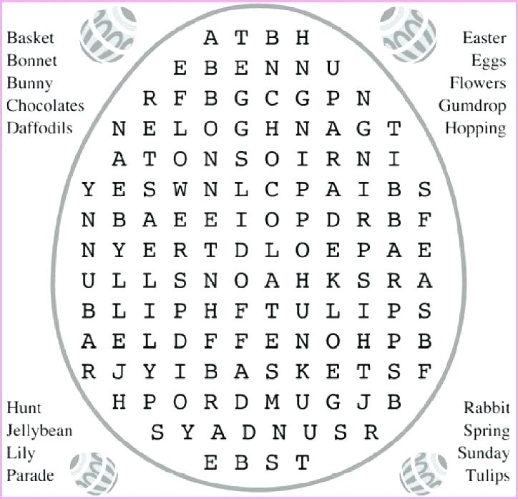

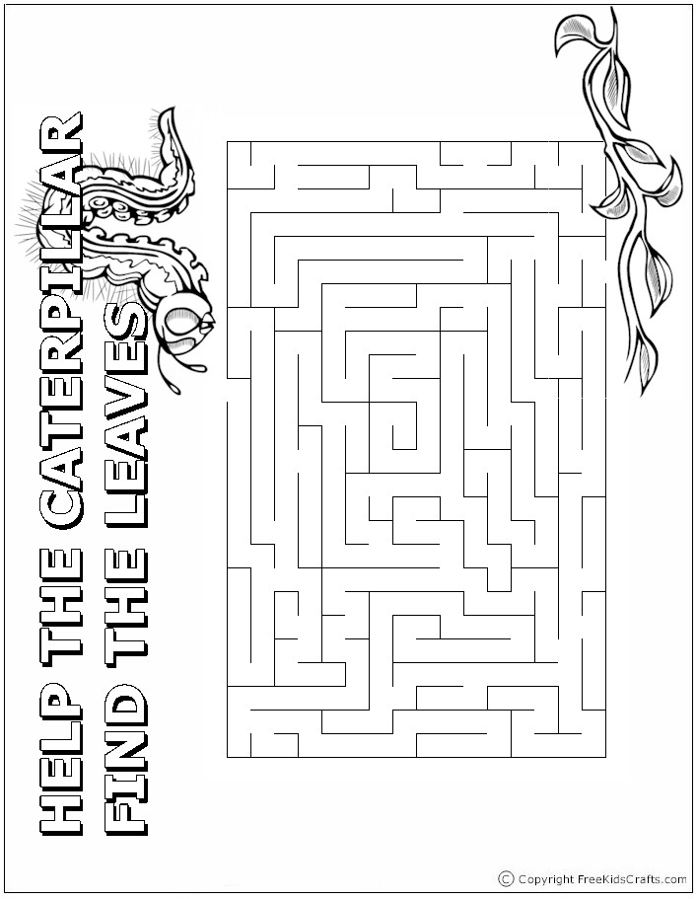
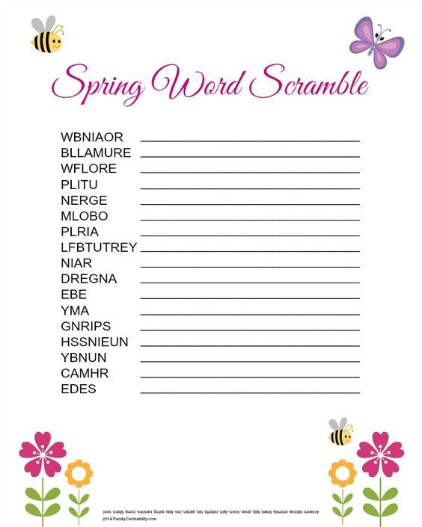
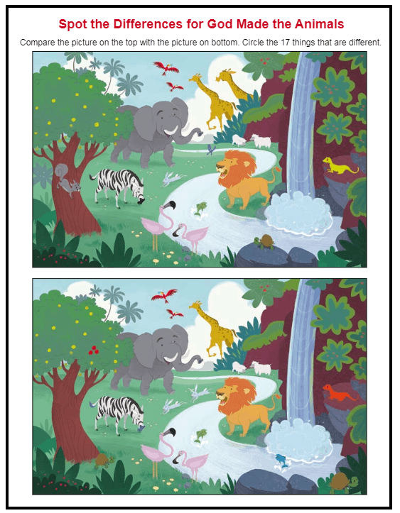
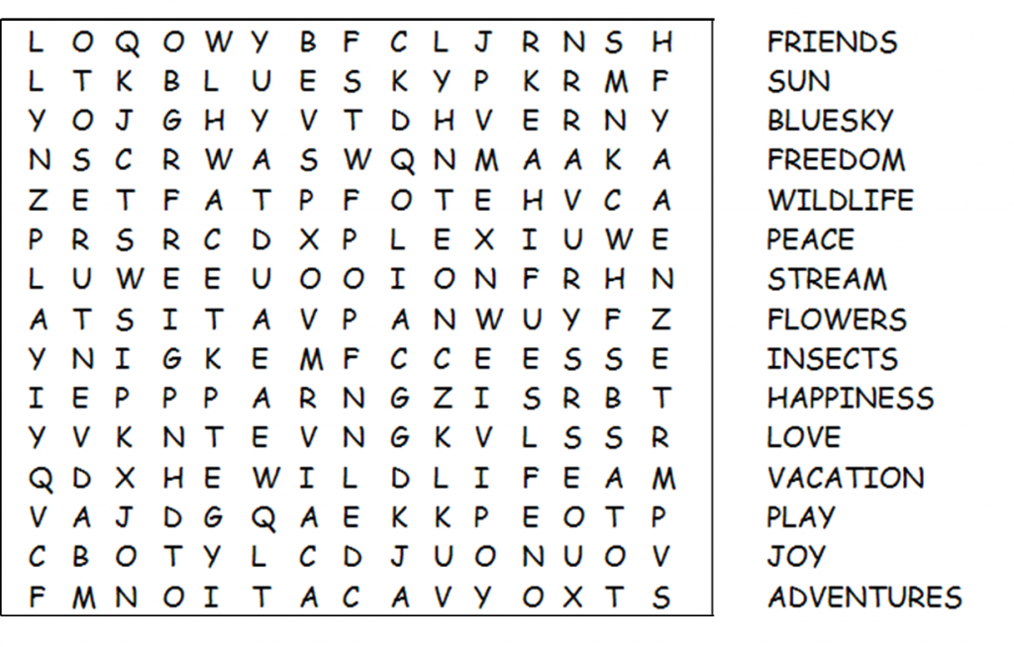

Now it’s time for those silly jokes to keep you smiling!

- What did the little mountain say to the bigger mountain?
Hi Cliff!
- What do you call a cow with 2 legs?
Lean beef
- My favourite word is “drool”.
It just rolls off the tongue
- Why is Peter Pan always flying?
He neverlands.
- Why do cows milking stools only have 3 legs?
Because the cows got the udder.

