Hi everyone, hope you’re all having a great week so far and excited for the lockdown to be gradually lifted!

Today we have some colouring pages for you all, so we hope you enjoy colouring/painting them!

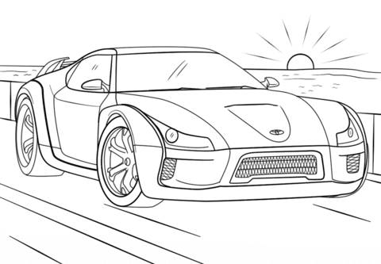

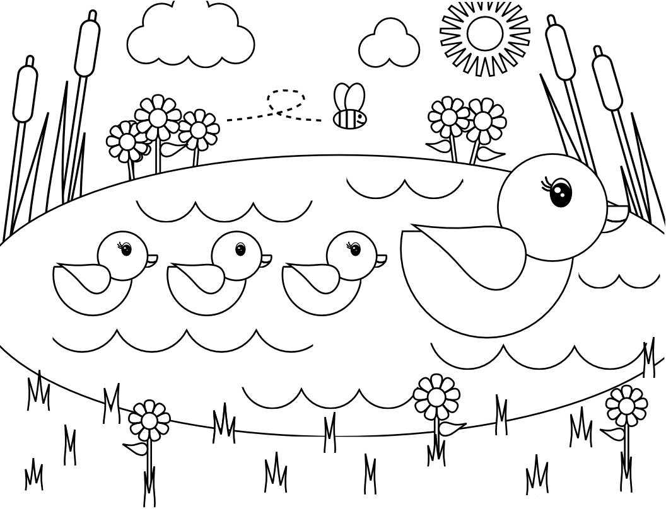
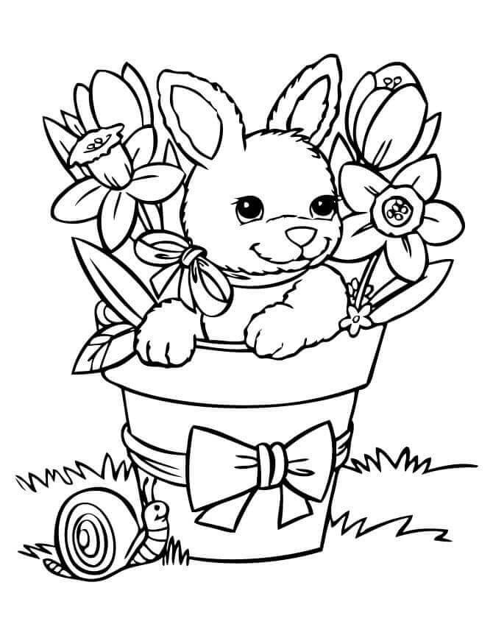

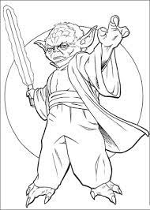
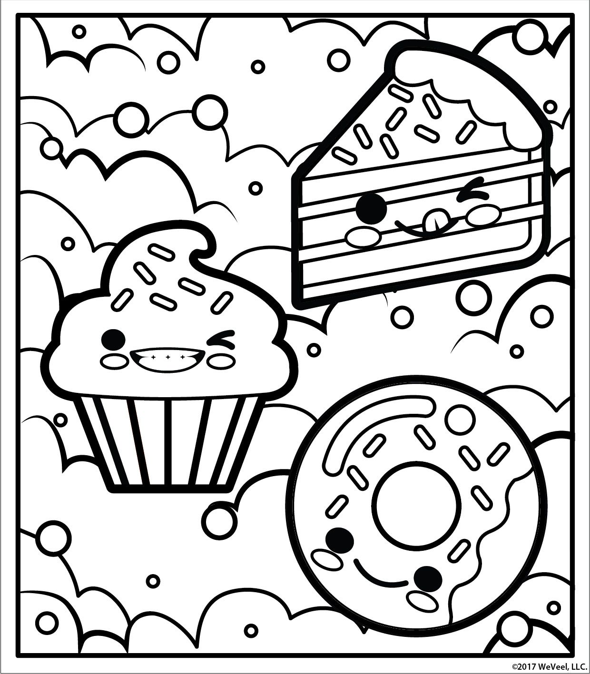

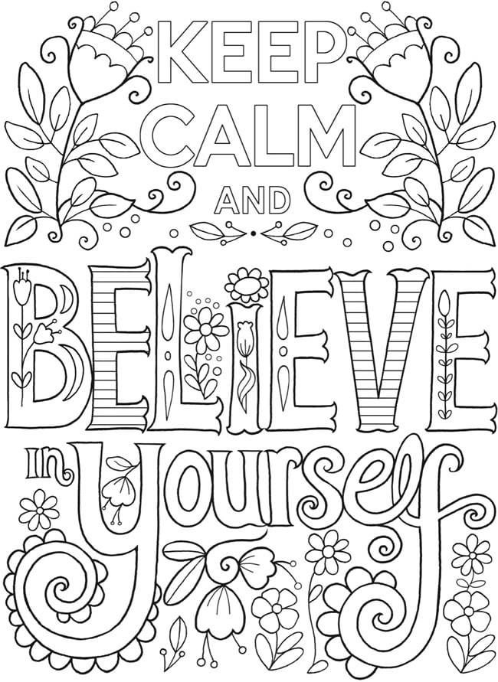
Now it’s time to make you all smile (if you aren’t already smiling)… yes you’ve guessed it, it’s the silly jokes!!!

- How did Darth Vader know what his parents got him for Christmas?
He felt his presents
- Why shouldn’t you write with a broken pencil?
Because it’s pointless
- I was sitting in traffic the other day….
Probably why I got run over
- Why don’t ants get sick?
They have anty-bodies
- Sometimes I just tuck my knees into my chest and lean forward…
That’s just how I roll
- What does a house wear?
A-ddress!
- Five guys walk into a bar…
You’d think one of them would have seen it!
- What do you give a sick bird?
Tweetment
- What do you call the security guards outside of Samsung?
The Guardians of the Galaxy

