Hightlighted areas are all examples of text and can be amended to suit your services.
DATE

  - Livability Service Name
We are now supporting more than 40 people to live meaningful lives with as much independence as possible. We have a staff team of over 60 who are all committed to ensuring your loved ones receive the best possible support.

During 2019, we were awarded new contracts and are reaching out to more people than ever before – this is a great achievement for the and would not have been possible without support from yourselves and our teams – Thank you!
Our connections with family are very important to us and we hope you will find this update helpful. We would like to introduce Family Forums in 2020 and further details are available in the Events/ Plans section.
We are extremely proud of Livability and hope that you will continue to support us.

Any Update you wish to advise, i.e. Management Update

Text
Insert photo
Text
Text
Text
Text

XXX contact details are:

XXXXXXXX@livability.org.uk
Mobile: 0123456789

As a mangement team, we all work closely together to ensure everyone gets the best possible support.

Livability will update you further when the review of the management model and consultation period is complete.

Enabling Support Workers
Please join me in welcoming to the team:

Insert Staff New Staff names

Livability are commited to becoming a real living wage employer and with this, we have been advertising for ‘Enabling Support Workers’ in place of ‘Support Workers’. This is a positive change and one which will strengthen our commitment to provide the highest quality support .

Should you have any questions about this enabling worker role, please do contact me: 0123456789 or xxxxxxxxxxxxxxxx@livability.org.uk

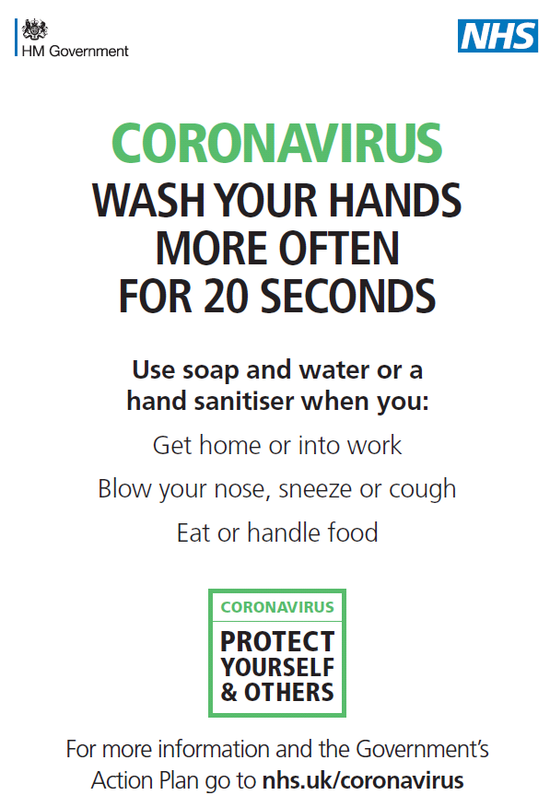
Any Update you wish to advise, i.e. Infection Control – COVID-19
Livability have introduced a new policy in light of the recent outbreak of COVID-19.
We have a robust plan in place to manage this and are reviewing the situation on a daily basis.
Our contingency plan involves reviewing our provision of essential and non essential support. If you or your family are likely to be affected by this, we will contact you directly by telephone to talk about this.
We are operating as usual at the moment and will update you as and if the situation should change.

Any Update you wish to advise, i.e. Events / Plans

Family Forum’s 2020 – We would like to hold more family forums in 2020. This will be an opportunity for all family members to come along to a venue to be confirmed, meet each other and have a cuppa. The forums will be designed to be informal, but there will be opportunity for you to speak 1:1 with members of management, give feedback and share any ideas you may have Livability. We will also share any organisational updates we can.

Friends Of Livability service name - We are looking for a chair, treasurer and secretary to help us set up Friends of Livability service name fundraising group. If you would like to be involved, or know anyone who would, please get in contact.

Suggestions & Ideas for improvements
We are always seeking feedback on how we can improve the service we deliver. Your views and comments are important to us. If you would like to give feedback – please do get in contact.

Contact Numbers
XXXXXXXXXXXXXXX – 0123456789
XXXXXXXXXXXXXXX – 0123456789
XXXXXXXXXXXXXXX – 0123456789
XXXXXXXXXXXXXXX – 0123456789
XXXXXXXXXXXXXXX – 0123456789
XXXXXXXXXXXXXXX – 0123456789

Emergency Contact – On Call

The local on call number is: 07932358035

On Call Manager is available for emergency situations from 5pm weeknights and 24 hours on a weekend or bank holiday.

Follow us on Twitter @LivabilityXXXXXXX
Like us on Facebook XXXXXXXXXXXXXXXXXXXX

