07 October 2020

Dear

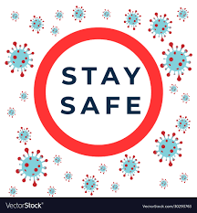 [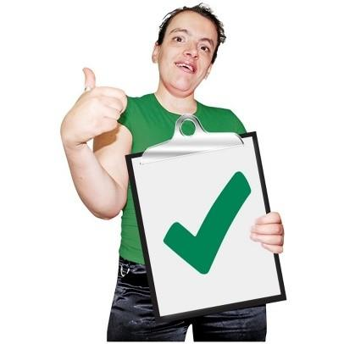](https://www.google.co.uk/url?sa=i&url=https%3A%2F%2Fwww.haringey.gov.uk%2Fsocial-care-and-health%2Flearning-disabilities%2Fbe-healthy%2Fhealth-services%2Foccupational-therapy&psig=AOvVaw1mp5b2zOBhbc5kXpcRcBR5&ust=1601999127392000&source=images&cd=vfe&ved=0CAIQjRxqFwoTCIiy8_zlnewCFQAAAAAdAAAAABAD)

I hope you are well and have stayed safe during the COVID-19 pandemic.

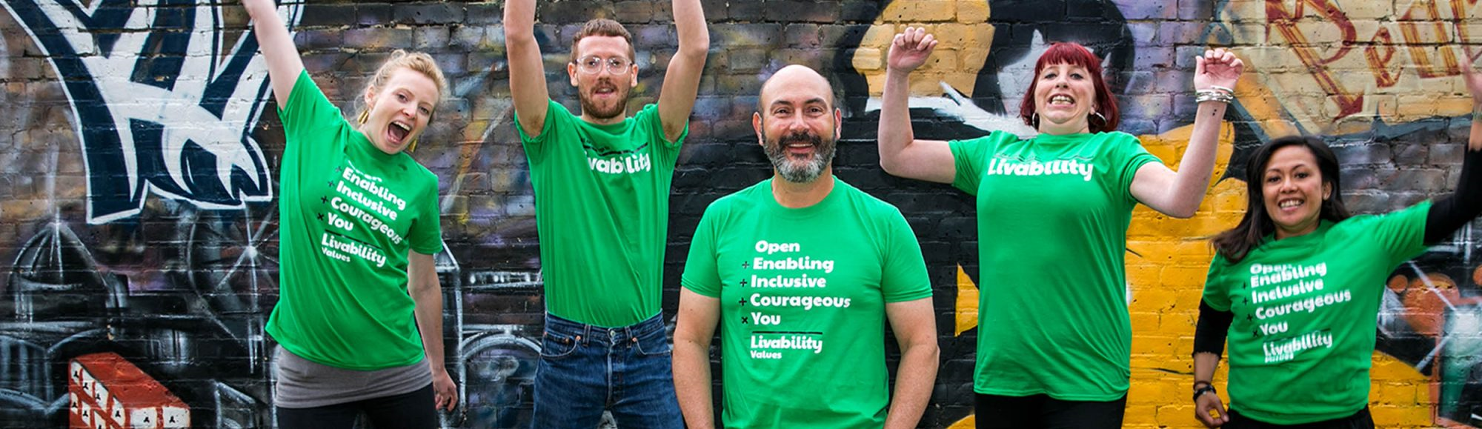

I am very proud of the fantastic staff that work for Livability and how hard they worked to keep people we support happy, safe and well during COVID-19.



COVID-19 is increasing again in England, Wales and Northern Ireland.

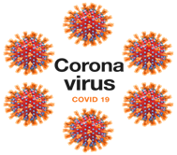

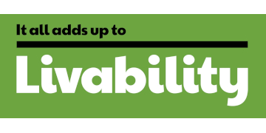

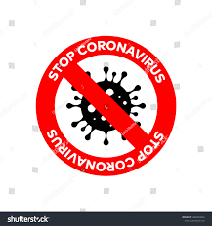

We are doing all we can to stop COVID-19 getting into Livability services and to keep you and our staff safe.

We are doing this by:

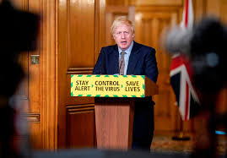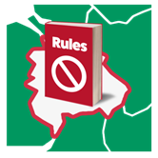

Making sure our managers and staff are kept up to date about any changes made by local authorities and governments in areas where we have services

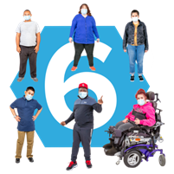



Encouraging people we support and our staff to take part in regular COVID-19 testing where this is available

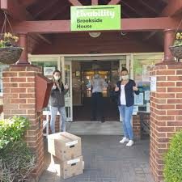

Making sure we have enough stocks of equipment like gloves, face masks and aprons to keep you, those you live with and our staff safe

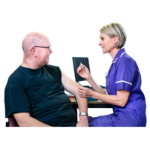

Encouraging people we support and our staff to have flu jabs.

Getting flu and COVID-19 at the same time can be dangerous. Having the flu jab reduces this risk. We have included a booklet about the flu jab with this letter.

[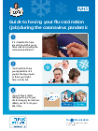](https://www.google.co.uk/url?sa=i&url=https%3A%2F%2Fwww.gov.uk%2Fgovernment%2Fpublications%2Fflu-leaflet-for-people-with-learning-disability&psig=AOvVaw1mFZh4-XWz5B150raID_9B&ust=1602089171627000&source=images&cd=vfe&ved=0CAIQjRxqFwoTCNjy7bm1oOwCFQAAAAAdAAAAABAO)

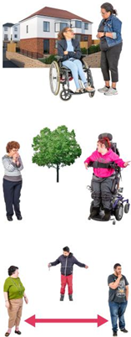

We know and understand that seeing visitors in and outside of your home has been difficult.

Because COVID-19 rates are increasing we need to keep the visiting arrangements we currently have in place. This is so we can continue to keep you, the people you live with and our staff safe.



 

We will keep looking at Government guidelines about visits.

We will change our arrangements when Governments say it is safe to do so. At the moment we think it might be several months before we can do this.





Some places have more COVID-19 cases than others.

These areas have different rules in place to help people keep safe.

In areas where there are different rules, we may have to stop visits to and from our services. We may also have to stop visits if COVID-19 cases across the country keep increasing.



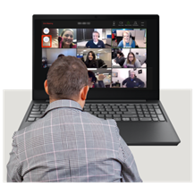

Stopping visits is not something Livability want to do. I just wanted to let you know that it is something we may need do to keep COVID-19 out of our services and keep everyone safe.

If we have to stop visits, we will do all we can to support you to keep in touch with your friends and family.





I hope this has brought you up-to-date with what we are doing to keep our services safe during COVID-19.

Please remember that **[ Insert Name (+Photo) ],** Service Delivery Lead for **[ Insert Service Name]** will be happy to talk to you if you have any questions about this letter.



I hope these actions will reassure you and your loved ones and help you to stay safe and well during COVID-19.



[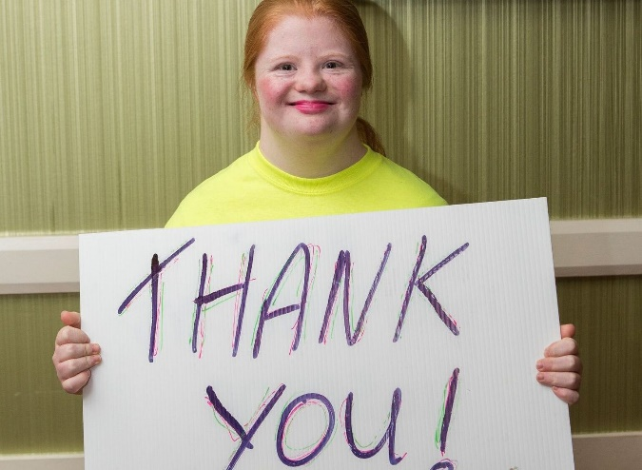](https://www.google.co.uk/url?sa=i&url=https%3A%2F%2Fdownsyndrome.ie%2Fdonate%2F&psig=AOvVaw3OqiW7dHi895FSMZk5KvdH&ust=1601999383217000&source=images&cd=vfe&ved=0CAIQjRxqFwoTCND1pfvmnewCFQAAAAAdAAAAABAD)

I would like to end by thanking you for your co-operation, patience and support during this difficult year.

Yours sincerely

Jane Percy

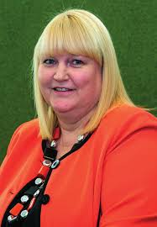

Executive Director of Operations

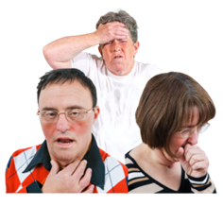

**We all need to take care to stop people catching and spreading COVID-19.**

**We can do this by remembering:**

