**Staff are wearing PPE to ensure they keep everyone safe**

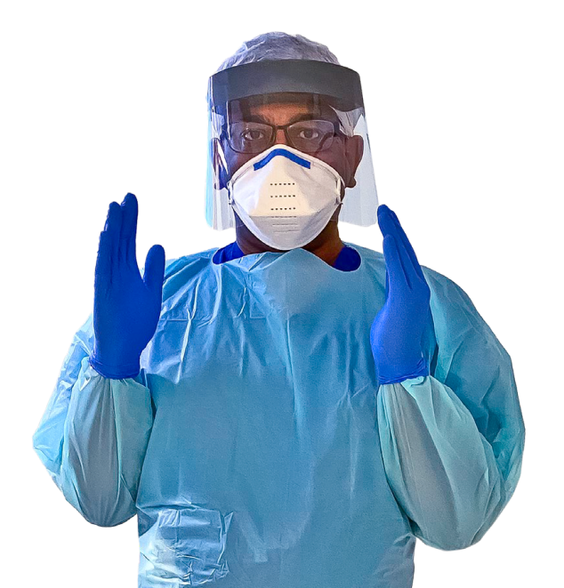

**Don’t be scared**



Support workers may look different; this is because they are wearing extra protection called **PPE – which could be**

* Face masks 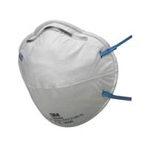[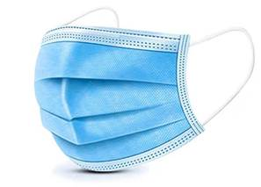](https://www.google.co.uk/url?sa=i&url=https://m.gearbest.com/braces---supports/pp_3007493054791007.html?wid%3D2000001&psig=AOvVaw11G7cjz8LCO_uPpNIyLNvI&ust=1586933894189000&source=images&cd=vfe&ved=0CAIQjRxqFwoTCKi00cqr5-gCFQAAAAAdAAAAABAE)
* Face shields 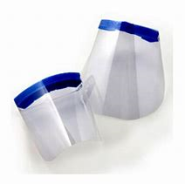
* Gloves 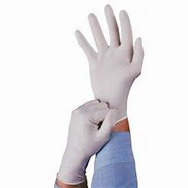
* Aprons 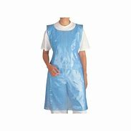



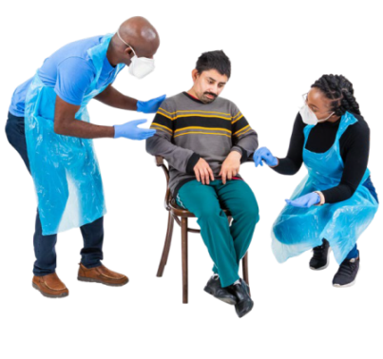PPE helps staff work safely during the coronavirus outbreak

PPE helps stop the

**coronavirus** spreading to other people

Underneath it is still the same person supporting you