DATE HERE

Dear PERSON SUPPORTED NAME

You might have heard about a virus called Coronavirus. Livability needs to plan in case Coronavirus affects our services. I am writing to tell you about that plan.

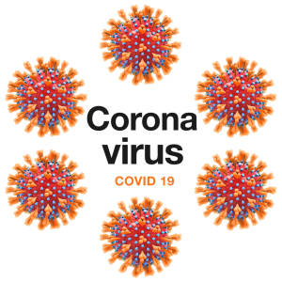
What is Coronavirus?
There are lots of different Coronaviruses. The one we are worried
about is called COVID-19. When a person gets COVID-19 they can have a:

- Shortness of breath
- Fever
- Cough

Most people who get COVID-19 will get better after a while but they should get plenty of rest and drink fluids.

COVID-19 can be a lot worse for people who are elderly or who already have health problems.
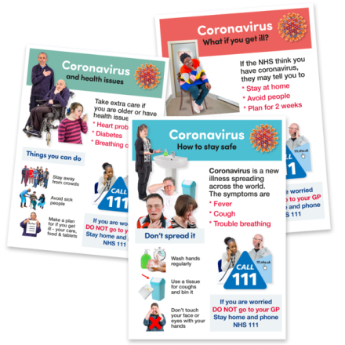
We can provide you with more information about COVID-19.

What Livability are Doing
We have thought about what we need to do to reduce the chance of you and our staff catching COVID-19.

We have also thought about what we need to do if you or our staff catch COVID-19.

We are gathering information everyday about COVID-19. This will help us to make sure we are doing the right things to protect you and your staff.
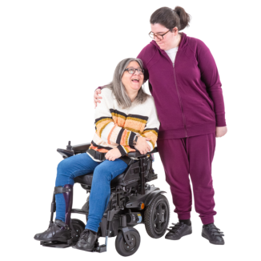
If a lot of our staff catch COVID-19 we might need to change the amount of support you receive. We will tell you about this and ask what your thoughts are. We will also tell the people funding your support.

We might have written to your family or representative to find out if they can offer you support if a lot of our staff get sick.

Sensible Precautions
We will be making sure we have more cleaning tasks happening at our services.

We will be encouraging you, our staff and any visitors to wash hands regularly.
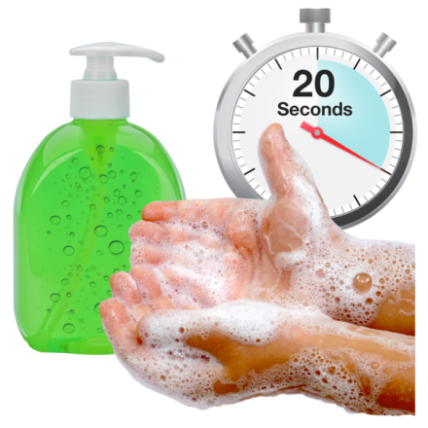

We might have to stop visitors from coming into your service. We will think about ways you can still contact your family and friends such as by using the telephone.
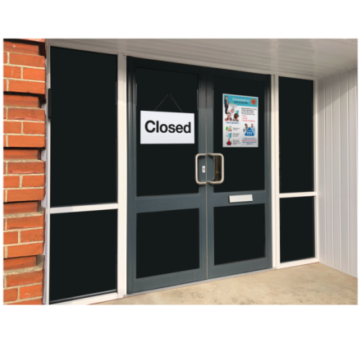

If you have a cough or a high temperature you might have to self-isolate. This is the government advice and means you might have to stay in a particular room until you feel better.

If you become unwell we will contact your doctor or the NHS for advice and support.

What to do next
We will tell you if anything has to change because of COVID-19.

We do not want to you to worry. We are writing so you know what is happening and why.

If you want to talk about this with anyone the best person is named below

Name of Contact | SERVICE MANAGER/ DEPUTY MANAGER/ KEYWORKER
Role
Email Address
Telephone Number

Thank you for reading this letter.

Yours sincerely

Jane Percy
Executive Director of Operations

