Dear

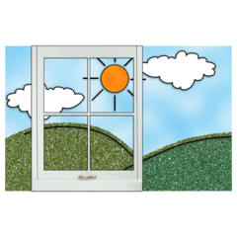

I hope you are well and have been enjoying the lovely sunny weather we have had recently.

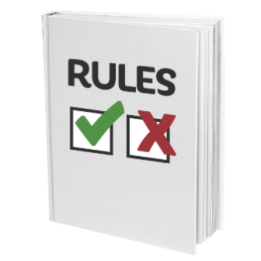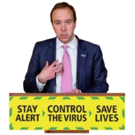

I am writing to update you about the changes Livability have put in place following the Government changing some of the coronavirus rules last week.

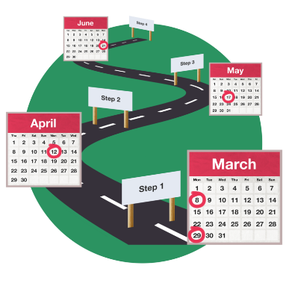

The changes are part of the Governments plans so:

* things can slowly get back to normal
* the changes can be made safely

You might have heard the plan called a ‘road map.’



I know how hard it has been not to see friends and family during COVID-19. I am very pleased that some of the changes made in the road map are about people visiting you indoors and outdoors. These changes mean that you can now see more people than the one person you have been seeing recently.

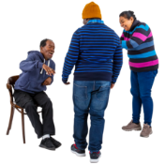



All visits will continue to be for one hour and will need to be pre-booked. This is to make sure everyone has the opportunity to see their friends and family members.



The safest place for visits to take place is outdoors. If visits can’t take place outdoors, two people can now visit you indoors. Your two indoor visitors must always be the same two people and their names should be in your care plan. They can visit you together with your other indoor visitor or on their own. Please let the staff that support you know who you would like your extra visitor to be.

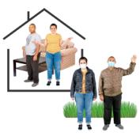

As well as the two visitor’s named in your care plan, you can also see up to two other people outdoors. These people can be different to the two people you have named to see indoors in your care plan. They can also visit you separately or together.

In Livability homes where there is enough space and a big enough window, it may be possible for you to see 4 people. This is the maximum number of people you can see at any one time. This will be the two indoor visitor’s named in your care plan and two outdoor visitors.

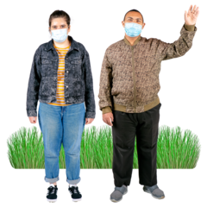

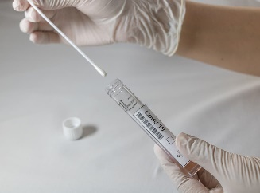

All visits need to be booked and you and your visitors will have to keep to the rules about hands – face – space. Your indoor visitors will still have to have a COVID-19 test and wear PPE.



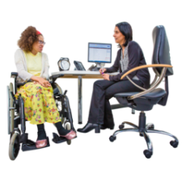

Livability are also following new government guidance about visits outside of our homes. One of the new rules is that you will have to self-isolate for 14 days after any appointments or trips outside of your home. This could be a short trip like a doctor’s appointment or shopping trip or a longer trip, such as an overnight stay like a hospital stay, going to your day-service or following a day out with a friend or family member.

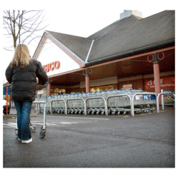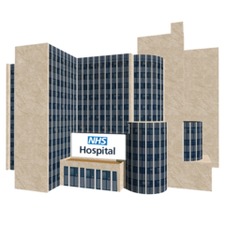

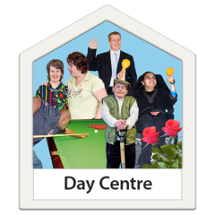

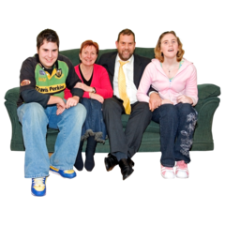

COVID-19 is still around and these changes have been made to keep you safe. Whilst the vaccine means that you may not get as poorly if you do catch COVID-19, it does not meant that you and other people cannot get or spread COVID-19 to others. Spending 14 days self- isolating if you do go will help to keep the people you live with and the staff that support you safe.

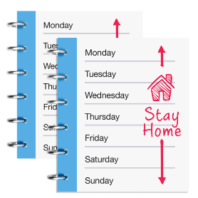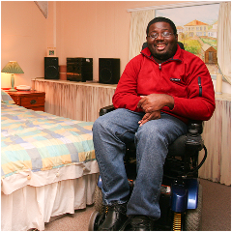

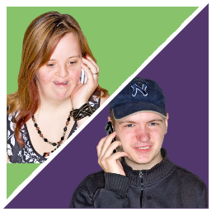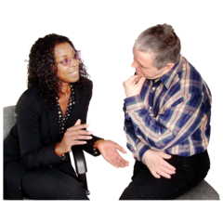

I know that being asked to self-isolate after any time spent out of your home will be difficult. If you do need to isolate, the staff that support you will talk about what this means and will write a care plan about this with you. This will include how to support you to stay in touch with the people that are important to you and the things you can do to keep busy whilst you are self-isolating.

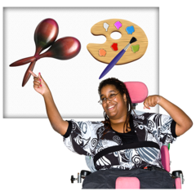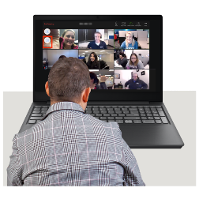

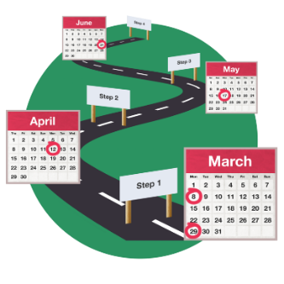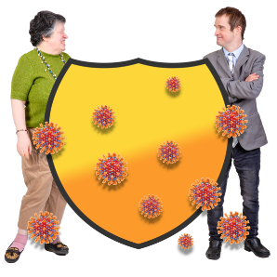

I want to remind you that these changes have been put in place by the Government to keep you, the people you live with and Livability staff safe. Livability’s priority throughout COVID-19 has been to keep everyone safe. This is something we have done really well thanks to your support and patience and our amazing, dedicated staff teams.

The Government are keeping a close eye on COVID-19 as things start to open up. They have said that they will update their guidance about visits and isolating after time outside of a care home when it is safe to do so. I really hope that this is soon.

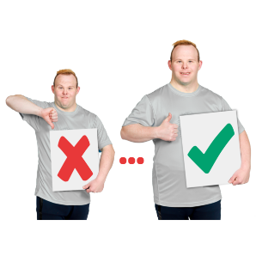

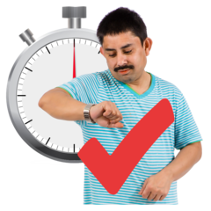

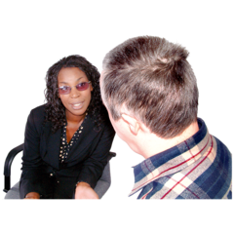

Please speak to the service delivery lead or area manager of your service if you would like to discuss any of the information in this letter.



I hope you continue to stay safe and well.

Yours faithfully



Jane Percy

Executive Director of Operations